Data Analyst – Clustering Analysis Documentation

1. Role Overview
As the Data Analyst specializing in Clustering Analysis, my responsibility was to apply clustering techniques to segment customers based on similarities in customer behavior, specifically focusing on tenure and monthly charges.
The objective of this analysis was to identify meaningful customer groups that could support business decision-making, customer retention strategies, and further analysis by the project team.
The key responsibilities completed during this stage included:
- Selecting and applying an appropriate clustering algorithm.
- Determining the optimal number of clusters using the Elbow Method.
- Training the clustering model using the prepared dataset.
- Analyzing and interpreting customer segments.
- Visualizing clusters to support understanding and communication of insights.

2. Data Preparation
The analysis used the cleaned customer dataset provided by the Data Engineering team.
The dataset contained:
- Total customer records: 6,741
- Selected clustering features:
  - Tenure
  - MonthlyCharges
These features were selected because they represent important customer characteristics:
- Tenure indicates the length of the customer's relationship with the company.
- Monthly Charges indicate customer spending behavior and value.
Before applying clustering, the selected features were extracted from the dataset:
X = df[['tenure', 'MonthlyCharges']]
Since tenure and monthly charges have different scales, feature standardization was performed using StandardScaler. This ensured that both features contributed equally during the clustering process.
The scaled dataset produced:
X_scaled.shape = (6741, 2)
This confirmed that all 6,741 customer records were successfully prepared for clustering.

3. Clustering Algorithm Selection
The K-Means clustering algorithm was selected for customer segmentation.
K-Means was chosen because:
- It is suitable for grouping customers based on numerical similarities.
- It is efficient for large datasets.
- It provides clear cluster assignments that can be easily interpreted.
- It is commonly used for customer segmentation analysis.
The algorithm groups customers by minimising the distance between customer data points and their assigned cluster centre (centroid).

4. Determining Optimal Number of Clusters
To identify the most appropriate number of customer segments, the Elbow Method was applied.
The Elbow Method evaluates different values of K by measuring the Within-Cluster Sum of Squares (WCSS).
The WCSS values were calculated for cluster numbers from 1 to 10:
Number of Clusters (K) | WCSS
1 | 13482.00
2 | 7729.97
3 | 4434.86
4 | 2796.90
5 | 2319.92
6 | 1900.08
7 | 1639.17
8 | 1333.36
9 | 1259.97
10 | 1114.54
The Elbow Method graph showed that improvement became less significant after K = 4.
Therefore, four clusters were selected as the optimal number of customer segments.
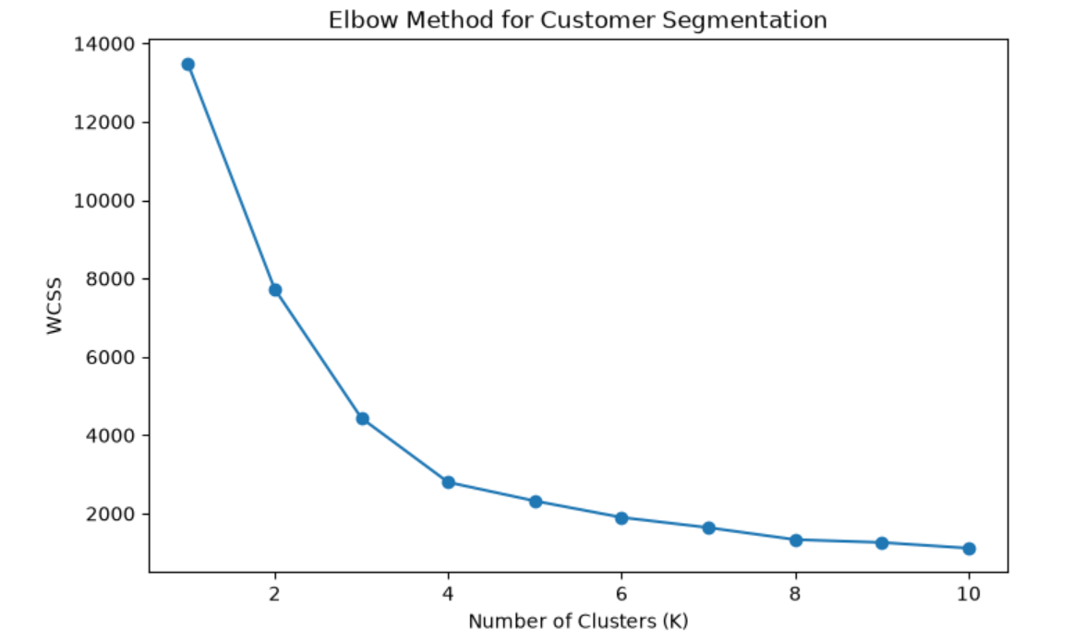
Figure 1: Elbow Method

5. Model Training
The K-Means clustering model was trained using four clusters.
The model configuration was:
KMeans(
n_clusters=4,
random_state=42
)
The model successfully assigned every customer record into one of the four clusters.
Example cluster assignments:
[0, 3, 3, 1, 3, 2, 1, 2, 2, 0]
The cluster labels were added to the original dataset for further analysis.

6. Cluster Results and Interpretation
The clustering model identified four customer segments.
Cluster | Average Tenure | Average Monthly Charges | Customer Count
Cluster 0 | 11.34 months | $33.76 | 1,591
Cluster 1 | 14.93 months | $81.66 | 2,125
Cluster 2 | 58.58 months | $93.04 | 1,914
Cluster 3 | 54.17 months | $34.67 | 1,111

Cluster 0 – New Low-Charge Customers
Customers in this cluster have:
- Short customer tenure.
- Low monthly charges.
These customers are relatively new and may require improved onboarding experiences and engagement activities to increase loyalty.

Cluster 1 – New High-Charge Customers
Customers in this segment have:
- Short tenure.
- High monthly charges.
Although these customers generate higher revenue, they have not maintained a long relationship with the company. Additional customer support and satisfaction initiatives may help improve retention.

Cluster 2 – Long-Term High-Value Customers
This cluster represents:
- The longest average tenure.
- The highest monthly charges.
These customers are considered high-value customers because they contribute significant revenue and demonstrate long-term loyalty.
Retention strategies should prioritise this group.

Cluster 3 – Long-Term Low-Charge Customers
Customers in this group have:
- Long tenure.
- Lower monthly charges.
These customers show loyalty but contribute lower revenue. The business could explore opportunities such as service upgrades or personalised offers to increase customer value.

7. Cluster Visualisation
A scatter plot was created to visualise the customer segments.
The visualisation used:
- X-axis: Customer tenure
- Y-axis: Monthly charges
- Colour: Cluster assignment
The visualisation showed clear separation between customer groups based on their tenure and spending behaviour.
The graph helped communicate:
- Differences between new and existing customers.
- Identification of high-value customer groups.
- Opportunities for targeted business strategies.
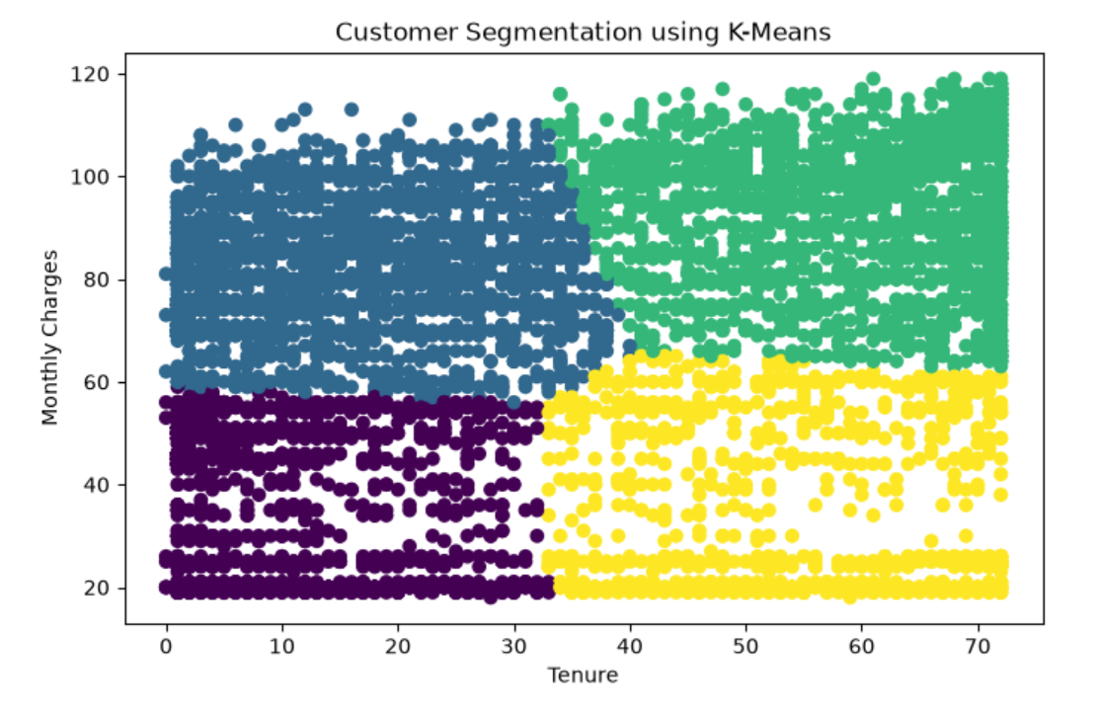
Figure 2: K-Means Method

8. Key Findings
The clustering analysis successfully segmented customers into four meaningful groups.
The major findings were:
- Customer behaviour can be differentiated based on tenure and monthly spending patterns.
- Cluster 2 represents the most valuable customer segment due to:
  - Long customer relationships.
  - High monthly revenue contribution.
- New customers in Clusters 0 and 1 require additional engagement strategies to encourage long-term loyalty.
- Long-term customers with low spending (Cluster 3) provide opportunities for targeted promotions and service improvements.
- Customer segmentation provides useful insights that can support future churn analysis and customer retention planning.

9. Communication of Insights
The clustering findings and visualisations were shared with project team members to support further analysis.
The results can assist the team in:
- Understanding customer behaviour patterns.
- Identifying valuable customer groups.
- Developing targeted retention strategies.
- Supporting future predictive modelling and churn analysis activities.

10. Conclusion
The K-Means clustering approach successfully identified four distinct customer segments using tenure and monthly charges. The Elbow Method helped determine the optimal cluster number, while cluster analysis and visualisation provided meaningful business insights.
The outcomes of this analysis demonstrate how clustering techniques can be used to transform customer data into actionable information for business decision-making.

